Software Requirements Specification
for
File Transfer Protocol (FTP)
Version 1.0
Prepared by: Hardi Bhatt, Jing Zhao, Guojun Zhang
CSC 623: Data Communications and Networking
10/28/11
Table of Contents
Table of Contents ii
Revision History iii
1. Introduction 1
1.1 Purpose 1
1.2 Document Conventions 1
1.3 Intended Audience and Reading Suggestions 1
1.4 Project Scope 1
1.5 References 2
2. Overall Description 2
2.1 Product Perspective 2
2.2 Product Features 2
2.3 Operating Environment 2
2.4 Design and Implementation Constraints 2
2.5 User Documentation 3
3. System Features 3
3.1 System Feature 1 3
3.2 System Feature 2 (and so on) 4
4. External Interface Requirements 4
4.1 User Interfaces 4
5. Member Ranking 5

Revision History
https://networking.beanstalkapp.com/session/new
Username: Networking
Pass: Communications

Introduction

Purpose
Work in groups of 3 or 4 people to implement a GUI-based file transfer protocol (FTP) client and a multi-threaded FTP server as follows.
- Both the client and server are written in Java.
- The multi-threaded server runs on Maxwell but the GUI client can run any PC.
- Once the client is loaded, there should be a window (similar to WinSCP) showing the local and remote directories.
- Users should be able to drag files from the local host to the remote server and vice versa.

Every team must have a leader who should identify his team members to me in an email by the date indicated above (11/9/2011)

Document Conventions
To keep everyone on the same page, we will be following naming conventions for all of our Functions, Methods, Variables and Classes for this project.

Naming Conventions:

- Classes: The Two main classes we will be working off of are the “Server” and “Client” classes. Additional classes will be required to follow the same naming convention with the first alphabet of the class name being capital (Ex. “ServerWorker”) following the Letter-case separated words convention or Camel Caseing. Which is the practice of writing compound words or phrases in which the elements are joined without spaces, with each element's initial letter capitalized within the compound and the first letter either upper or lower case. For the Purposes of the Class the first letter will be in upper case.
- Functions and Methods: Same as Classes it will be structured using Camel Caseing however for Functions and Methods the First letter will be in lower case (Ex. serverConstructor).
- Variables: Both Local and Global variables will be following Delimiter-separated words using an underscore to separate two words (ex. two_words). Global Variables for any class will be in all upper case (ex. for global variables: COUNT_ONE) so that they can be distinguished between local variables easily which will all be in lowercase (ex. loc_count).

Intended Audience and Reading Suggestions
The intended audiences for this project are developers and users who intend to transfer documents between two devices.

Project Scope
To Create a FTP Client and Server which can transfer documents and other software packages between each other.

References
For references we will use online tutorial for Java Swing and Socket switching tutorials from the links below.
http://www.javabeginner.com/java-swing/java-swing-tutorial
http://java.sun.com/developer/technicalArticles/ALT/sockets/
http://download.oracle.com/javase/tutorial/uiswing/

Overall Description

Project Perspective
In this project we will work in group of 4 to implement a GUI-based file transfer protocol (FTP) client and a multi-threaded FTP server.

Project Features
This project will feature a multi-threaded server runs on Maxwell but the GUI client can run any PC. Both the client and server are written in Java. Once the client is loaded, there should be a window (similar to WinSCP) showing the local and remote directories. Users should be able to drag files from the local host to the remote server and vice versa.

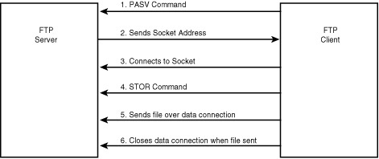

Operating Environment
The IDE we will be using for this project is Eclipse.

Design and Implementation Constraints
Working in a group will always present obstacles in working time, amount of work being done and when the work will be completed.

User Documentation
This document will be the only requirements document that will be provided.

System Features
Detailed features will be presented in the appendix.

GUI-based file transfer protocol
3.1.1 Description and Priority
Implement a GUI-based file transfer protocol (FTP) client.
3.1.2 Functional Requirements
Documentation and Presentation:
- Commented and indented code
- Well-written and well-organized report containing all pertinent details (description.html)
- Is ranking statement (ranking.html) included?
- How well is the work presented?
- Is the application in working order at the time of presentation? Can files be successfully downloaded from one machine to another using this protocol?

Technical Merit:
- Can the client correctly exchange information with the remote server?
- Can the client and server exchange any type of file such as text, binary, images, etc.?
- Is error checking performed?
- Is the server multi-threaded?
- Is the client robust enough to handle the case when the server is down?
- Is the client design user friendly and intuitive?
- Can the server also run on a non-Unix machine?

Extra Credit:
- Renaming a file on the local or remote machine (right-click of the mouse)
- Deleting a file on the local or remote machine (right-click of the mouse)
- Allowing client to switch between different servers through the GUI.

Multi-threaded FTP server
3.1.1 Description and Priority
Implement a multi-threaded FTP server.
3.1.2 Functional Requirements
Documentation and Presentation:
- Commented and indented code
- Well-written and well-organized report containing all pertinent details (description.html)
- Is ranking statement (ranking.html) included?
- How well is the work presented?
- Is the application in working order at the time of presentation? Can files be successfully downloaded from one machine to another using this protocol?

Technical Merit:
- Can the client correctly exchange information with the remote server?
- Can the client and server exchange any type of file such as text, binary, images, etc.?
- Is error checking performed?
- Is the server multi-threaded?
- Is the client robust enough to handle the case when the server is down?
- Is the client design user friendly and intuitive?
- Can the server also run on a non-Unix machine?

External Interface Requirements

User Interfaces
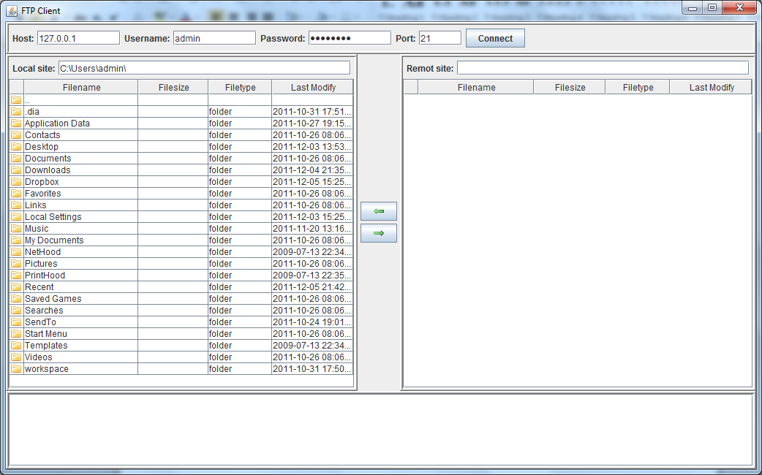
Client side GUI

Member Ranking
Member 1: Hardi Bhatt
My teammate and I agree that I handled 33% of the overall project. My specific tasks included:
Task 1: I Established the Repository
Task 2: Create all documentation
Task 3: Managed work schedule for team
Task 4: Created the Client GUI
Member 2: Guojun Zhang
My teammate and I agree that I handled 33% of the overall project. My specific tasks included:
Task 1: Created the Client Code
Task 2: Created Encryption and Decryption
Task 3: I researched RFC959
Task 4: I integrated and tested ftp client and server on Maxwell
Member 3: Jing Zhao
My teammate and I agree that I handled 33% of the overall project. My specific tasks included:
Task 1: Created the Server Code
Task 2: Helped with Client GUI
Task 3: Helped with Drag and Drop
Task 4: Helped with Encryption and Decryption
Member 4 Jing Zhao
My teammate and I agree that I handled 1% of the overall project. My specific tasks included:
Task 1: Owing me a Dollar

